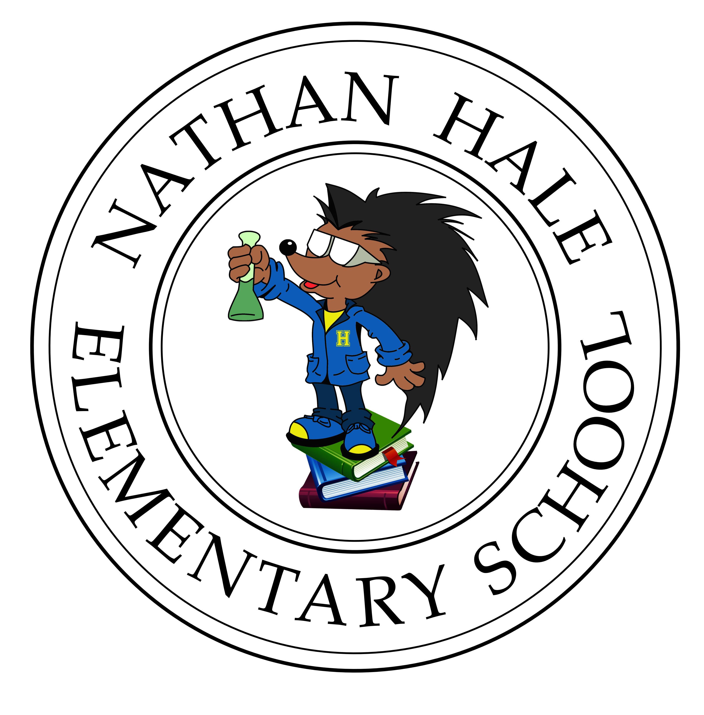

**3 Cheers For The Hale!**

To date, we have distributed 108 Chromebooks into the homes of our students.

We have also distributed an additional 3 Chromebooks in support of additional BPS students that are siblings to a Hale student. This brings the total of 111 Chromebooks in the hands of BPS students.

Our teachers are rock stars! They are teaching virtual classes, taping lessons and working in small groups with our students.

In an effort to support schools’s, the office of Data and Accountability has been tracking our student’s data and has organized it for our preview. Below, you can find the link to see the amazing work that is being done by one and all.

<https://datastudio.google.com/u/0/reporting/1kxdSqQ760Uhyq6f1-a2aL8Ipy8N-rsqa/page/YcpLB>

**Hale Virtual Learning**

If you are looking for additional resources and information, you can find it on our school website at

[www.nathanhaleroxbury.org](http://www.nathanhaleroxbury.org)

**MCAS TESTING**

As many of you may know, the department of Education has formally cancelled MCAS testing for this school year.

**Facebook**

We now have a new Facebook page for the Nathan Hale Community. We invite you to share some of your wonderful learnig or fmaily experiences with us during this virtua learning time.

<https://www.facebook.com/Nathan-Hale-Elementary-Roxbury-112557730157936/>

Please remember, that there is also a Facebook page for Families and Carevivers. Just search for Nathan Hale School Roxbury.

**April**

***Up and Coming Events***

**April 20th - April 24th**

**April Vacation Week**

Happy April vacation everyone! This will be a well deserved break for everyone. We know that you all have been working very hard to ensure that our student learning is continuing during our time away from the Hale.

We encourage you all to take the time to rest and simply enjoy your families and all of the many blessings we receive each and every day.

**Oh The Places You Can Go!**

**Are you looking for something fun to do over the school vacation week? Then, look no further and check out some of these free family fun activities.**

|  |  |
| --- | --- |
|  | Virtual Online Activities |
|  | [A Sailor's Life For Me: Dynamic Virtual Game...](https://www.bostoncentral.com/events/virtual/p64341.php) |
|  | [Amazing Magic Tricks for Kids](https://www.bostoncentral.com/events/virtual/p64193.php) |
|  | [April Make-A-Thon! with Boston Children's...](https://www.bostoncentral.com/events/virtual/p64275.php) |
|  | [Ben Rudnick performs 'Monster NO!' for kids...](https://www.bostoncentral.com/events/virtual/p64301.php) |
|  | [Berkner Breaks with the Laurie Berkner Band...](https://www.bostoncentral.com/events/virtual/p64189.php) |
|  | [Boston Children’s Hospital Big Family Game...](https://www.bostoncentral.com/events/virtual/p64334.php) |
|  | [Boston Red Sox Kids Activity & Games Pages...](https://www.bostoncentral.com/events/virtual/p64361.php) |
|  | [Boston Yoga Online](https://www.bostoncentral.com/events/virtual/p64290.php) |
|  | [BSO at Home: Radio & Online Musical Offerings...](https://www.bostoncentral.com/events/virtual/p64171.php) |
|  | [BSO presents 'Concert for our City' (Streaming)...](https://www.bostoncentral.com/events/virtual/p64281.php) |
|  | [Christine's Virtual Critter Show LIVE](https://www.bostoncentral.com/events/virtual/p64165.php) |
|  | [Club Passim: 'Keep Your Distance Fest'](https://www.bostoncentral.com/events/virtual/p64264.php) |

The Nathan Hale Herald **Vol. 20. April 17, 2020 2020202020202020202020202020220020202020** 20100201912012019 2019